E1 Elimination
(Zaitsev Product)
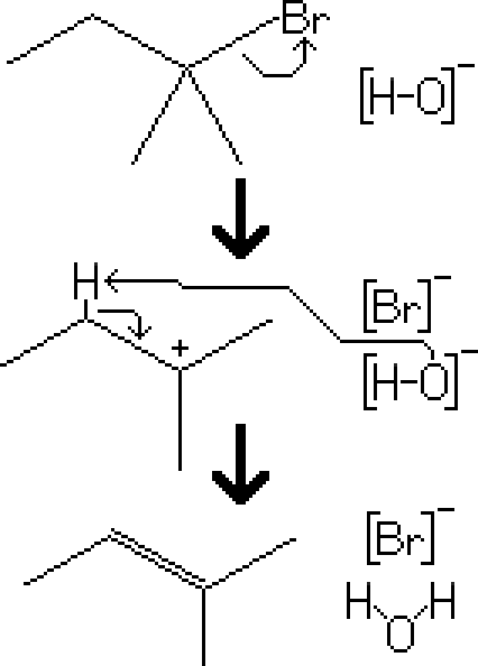
Reactants – Tertiary Alkyl Halide, t-BuOK
Products – Alkene (Hoffman), t-BuOH, Br⁻
Electron Movement
- E1 Reaction – The alkyl halide leaves the molecule, creating a carbocation intermediate. The hydroxide attacks a proton on the most branched beta carbon, and the electrons are distributed to the carbon-carbon bond, resulting in an alkene

Notes
- Note that this reaction results in a 4:1 ratio of the zaitsev product over the hoffman product.
- Because hydroxide isn't sterically hindered, it's more likely to take the proton of the most branched beta carbon. If it were more sterically hindered, then it would be more likely to take the proton of the less branched beta carbon, resulting in the hoffman product.

